Interface ID: OL-3/OL-4/OL-5
Created by: Mark Lund
Created Date: 10-24-2005

Description of Design Concept:
The Destroyed Vehicle, Abandoned Vehicle Reporting and Report of Sale Online web applications currently store finalized transactions in transaction tables in their respective databases. The finalized transactions are subsequently integrated to the VFS database and written to an IPC message file that triggers a call to a UAR update web service to post the transaction to the HQ Vehicle database. These activities are currently accomplished via 3 batch integration processes, vsIPOtoHP3, vsDestroyedIntegration and vsAVRIntegration that are scheduled to run every minute throughout the day. a new Windows Service (vsdVFSWebServiceIntegration) will replace the 3 batch processes.

The vsdVFSWebServiceIntegration service will be running throughout the day and will read the web application transaction tables looking for records that have been finalized, but have not been integrated. Rather than moving the records to the VFS for processing, the UAR update Web Service will be called directly. When a successful response is received from the update web service, the transaction record integration attribute will be set on, if a recoverable error response is received the record will be reprocessed, if a non-recoverable response is received a non-recoverable error attribute will be set on the record, an error email will be sent and the record will not be reprocessed until the error attribute has been manually reset (execution of a SQL script after error has been resolved).

Performance:
Transaction processing time is affected by network conditions but a duration of < 250ms per transaction is expected, and the process should be able to process well over 100,000 transactions within any 8 hour period.

Test #1 – 5 threads ~ 238ms/trans. or 15,126/hr
~ 121,000 extrapolated for an 8 hour day.
~ 151,260 extrapolated for a 10 hour day.
~ 181,512 extrapolated for a 12 hour day.
~ 363,025 extrapolated for a 24 hour period.

Decomposition/Flow Diagram:
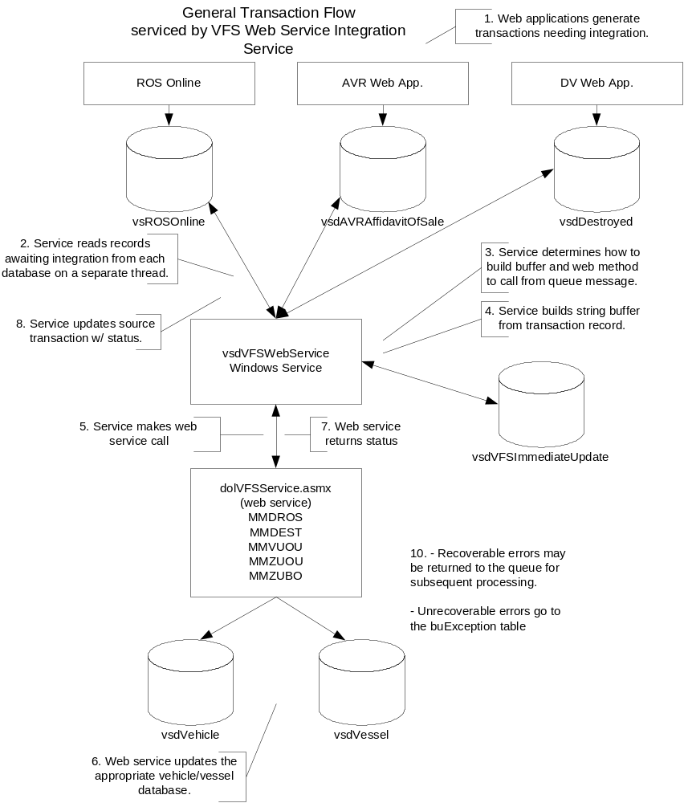

Functional Specifications:

Functionality:

- Web apps. generate records in SQL that need integration to the Unisys system.
- The service spawns a thread for each unique ConnectStringKey value in it’s buTranType table.
- The service calls a stored procedure per thread (database) to obtain a result set of records waiting for integration.
- Using parameters in the buTranType table, the service is able to determine which web service needs to be called based on the Tran Type associated with the ConnectStringKey.
- The UAR web service is called, passing in the buffer.
- The UAR web service updates the UAR vehicle/vessel database.
- The web service returns a status indicating success or failure.
- If the status is successful, the service updates the appropriate ROS, DV, or AVR record.
- If the status returned by the web service is not successful, or if the service is unable to communicate with the web service, the record is either retried at a later time or flagged as un-recoverable to be reconciled manually. Errors are deemed recoverable or non-recoverable by the return code of the web service response. The buResponseCode table contains the response codes.

Appendix A: Database Tables
Table: utAppConfig: the table would be used to define application processing and configuration parameters.
Attribute Name | Type | Length | Description
Process | Varchar | 50 | The name of the process a set of parameters is for.
Name | Varchar | 50 | The name of a parameter the calling process is interested. Process & Name create a unique parameter.
Value | Varchar | 255 | The parameter value
Comment | Varchar | 255 | Description of the parameter and how it is utilized.

Table: buTranType: this table defines the transaction types and associated processing details.
Attribute Name | Type | Length | Description
Process | Varchar | 50 | The name of the process a set of parameters is for.
TranType | Varchar | 8 | The transaction type of the record written to the queue..
URL | Varchar | 255 | URL of the web service to be called.
Method | Varchar | 50 | Web service method to be executed.
KeyOffset | Smallint | 2 | Not used by this process.
KeyLength | Tinyint | 1 | Not used by this process.
ConnectStringKey | Varchar | 50 | Connection key to the database for server availability
SPSelName | Varchar | 50 | Database select stored procedure name.
SPUpdName | Varchar | 50 | Database update stored procedure name.
SPKeyParaName | Varchar | 50 | The name of the key used by the update stored proc.
SPUpdParaName | Varchar | 50 | Not used by this process.
ProcessingOrder | Tinyint | 1 | Defines the processing order when a transaction type requires more than process call.
ResponseOffset | Tinyint | 1 | The starting position of the Response Code within the return buffer
ResponseLength | Tinyint | 1 | The length of the Response Code value.

Table: buResponseValue: defines the processing response associated with a Response Code value to accommodate a many to one relationship between the Response Codes and their associated processing response. For example OU00, RS00 and DV00 all indicate a successful update and trigger the processing of the next record in the queue.
Attribute Name | Type | Length | Description
Process | Varchar | 50 | The name of the process a set of parameters is for.
ResponseCode | Varchar | 4 | The status code returned by the web service/method call
ResponseValue | Tinyint | 1 | Processing response code associated with the one or many response codes.  0 = success / process next record  1= recoverable error / retry  2 = non-recoverable error / send email and set Integration Failed indicator  3 = recoverable error / send email and retry

